Algebra 1: Unit 2, Lesson 6

- Simplify the expression ${(r-4)}^{2}$ using the algebra tile model shown.
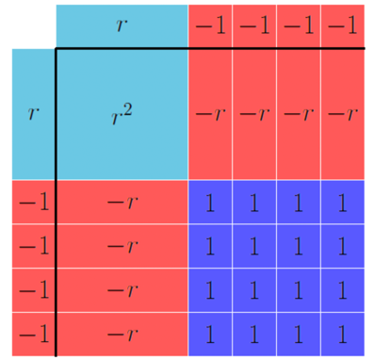
$$r^{2}-8r+16$$

- The algebra tile model shown displays the product of two binomials.
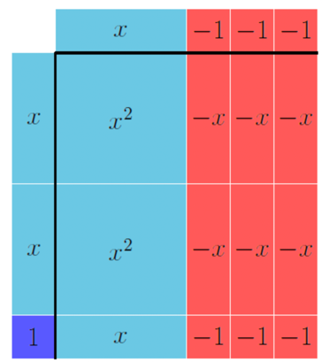
What two factors are multiplied to produce the equivalent expression $2x^{2}-5x-3$?
$$(2x+1)(x-3)$$

- What expression does the algebra tile model represent?
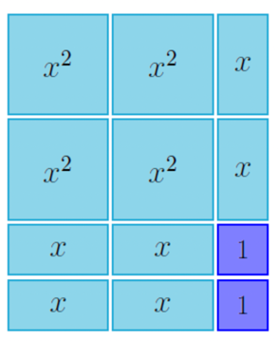
$$4x^{2}+6x+2$$

